DESIGN AND LTspice SIMULATION OF A
VOLTAGE-DIVIDER BIASED COMMON-EMITTER BJT AMPLIFIER
Project Design, Biasing, Transient Analysis, Troubleshooting and Verification

Topic: Common-emitter BJT voltage amplifier using a 2N3904 and LTspice
Purpose: Design, simulate, verify and troubleshoot a small-signal common-emitter amplifier
Simulation platform: LTspice
Report date: 25 August 2026
Name : Yogeswaran K
Reg No : 192412615

1. Executive Summary / Overview
This project studies a single-stage common-emitter (CE) BJT amplifier using a 2N3904 transistor in LTspice. The original circuit supplied for review contains a 12 V source, 4 kΩ collector resistor, 1 kΩ emitter resistor, 10 µF output coupling capacitor, 2 kΩ load and an input source defined as SINE(0 10m 1K).
The central finding is that the original circuit has no independent DC bias path for the transistor base. Because SINE(0 10m 1K) has zero DC offset, the base is approximately 0 V DC and the 2N3904 is driven toward cutoff. This explains the microvolt-level output seen in the supplied LTspice waveforms.
The recommended correction is a voltage-divider bias network using 82 kΩ from +12 V to the base and 15 kΩ from the base to ground, plus a 10 µF input coupling capacitor. First-order calculations give VB≈1.86 V, VE≈1.16 V, IE≈1.16 mA, VC≈7.36 V and VCE≈6.20 V. These are design estimates; the final values must be verified in LTspice.

2. Project Definition

2.1 Exact Topic
Design and LTspice simulation of a voltage-divider biased single-stage common-emitter BJT amplifier using a 2N3904 transistor.

2.2 Purpose
- Understand the DC bias requirements of a common-emitter BJT amplifier.
- Build and verify the circuit in LTspice.
- Apply a 10 mV, 1 kHz small-signal input and observe the output.
- Diagnose the original microvolt-level output.
- Introduce proper voltage-divider biasing and coupling capacitors.
- Compare hand calculations with LTspice operating-point results.
- Provide a beginner-friendly verification and troubleshooting procedure.

2.3 Target Audience
Beginner electronics students, project demonstrators, laboratory instructors and evaluators.

2.4 Content Requirements Included
- Original circuit and component values; theory; biasing problem; corrected design; calculations; LTspice procedure; waveform interpretation; troubleshooting; verification checklist; glossary; references/notes; appendices.

3. Original LTspice Circuit

3.1 Component Inventory
Reference | Component | Value / setting | Function
V1 | DC source | 12 V | Collector supply
V2 | Sine source | SINE(0 10m 1K) | AC input
Q1 | NPN BJT | 2N3904 | Amplifying device
RC | Resistor | 4 kΩ | Collector resistor
RE (shown as R2 originally) | Resistor | 1 kΩ | Emitter resistor
C2 | Capacitor | 10 µF | Output coupling
RL | Resistor | 2 kΩ | Load
Transient command | .tran | 10m | 10 ms simulation

3.2 Original Schematic
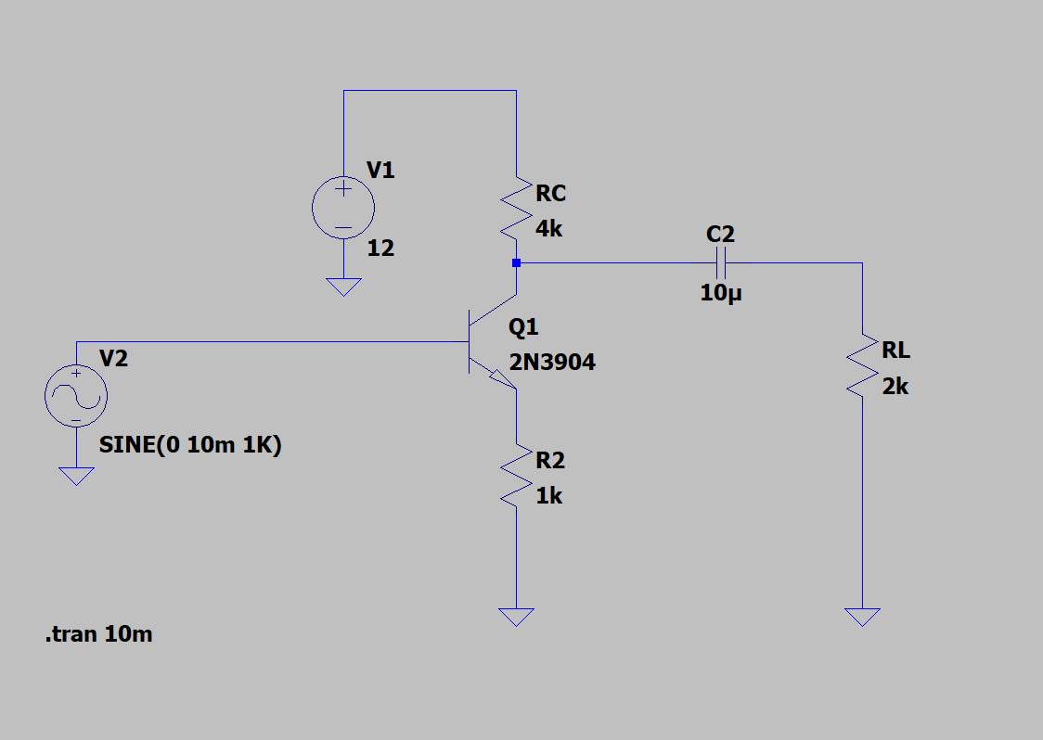
Figure 1. Original LTspice schematic supplied for the project.
The collector is connected to +12 V through RC, the emitter is connected to ground through the 1 kΩ resistor, and the collector is coupled through C2 to the 2 kΩ load. The input source is directly connected to the base.

3.3 What Is Correct
- 12 V supply is referenced to ground.
- RC=4 kΩ is placed between supply and collector.
- RE=1 kΩ is returned from emitter to ground.
- C2=10 µF couples the collector to the load.
- RL=2 kΩ is returned to ground.
- Q1 is a 2N3904 NPN transistor.

3.4 Critical Problem
The base has no independent DC bias network. The source SINE(0 10m 1K) is centered at 0 V, so the base does not receive the DC voltage needed to establish a useful forward-active Q-point.
- The transistor is near cutoff.
- A 10 mV AC signal alone does not establish the required DC operating point.
- The collector can remain close to the supply voltage while collector current is very small.
- The output can therefore be only a few microvolts.

4. Simulation Observations from Supplied Runs
The observations below are based on the LTspice screenshots supplied with the project. LTspice node names such as V(n002), V(n003) and V(n005) are automatically generated and should be confirmed by clicking the actual wire.
Input / condition | Visible result | Interpretation
SINE(0 10m 1K) | Output only a few µV | No DC base bias; transistor near cutoff.
V(n005) with zero-DC input | Approximately ±5 µV waveform | Extremely small response around an unsuitable Q-point.
SINE(0.1 1K) | Larger visible waveforms | Adding DC offset begins to turn the transistor on.
SINE(1 1K) | Hundreds of mV and nonlinear-looking waveforms | DC level and AC amplitude are too large for clean small-signal operation.
V(n002) readout | DC operating point about 524 mV | A biased node is visible in that run; exact terminal identity should be verified in the schematic.

Conclusion from the supplied evidence: changing the source DC offset changes transistor conduction, confirming that the missing DC bias is the main issue.

5. Common-Emitter Amplifier Theory

5.1 Operating Principle
In a common-emitter amplifier, a small change in base-emitter voltage causes a change in collector current. The collector resistor converts that current change into an output-voltage change. The stage normally provides voltage gain and inverts the signal.

5.2 Operating Regions
- Cutoff: transistor current is very small; the device is effectively OFF.
- Forward-active: suitable region for approximately linear small-signal amplification.
- Saturation: transistor is strongly ON; collector-emitter voltage is small and distortion can occur.

5.3 Why Biasing Matters
The transistor needs a quiescent operating point before the AC signal is applied. A suitable Q-point provides room for the collector voltage to move up and down without immediately reaching cutoff or saturation.

5.4 Roles of RE, C1 and C2
- RE provides emitter degeneration/negative feedback and improves DC stability.
- C1 isolates the source DC level from the transistor's bias voltage.
- C2 blocks the collector's DC voltage from the load while passing the AC output.

6. Corrected Circuit Design

6.1 Recommended Values
Component | Value | Connection
VCC | 12 V | +12 V supply rail
RC | 4 kΩ | +12 V to collector
RE | 1 kΩ | Emitter to ground
R1 | 82 kΩ | +12 V to base
R2 | 15 kΩ | Base to ground
C1 | 10 µF | Input source to base
C2 | 10 µF | Collector to output
RL | 2 kΩ | Output to ground
V2 | SINE(0 10m 1K) | 10 mV peak, 1 kHz input

6.2 Connection Sequence
- Keep V1 at 12 V DC and connect its negative terminal to ground.
- Connect RC=4 kΩ from +12 V to the collector of Q1.
- Keep Q1 as 2N3904.
- Connect RE=1 kΩ from emitter to ground.
- Add R1=82 kΩ from +12 V to the base.
- Add R2=15 kΩ from base to ground.
- Insert C1=10 µF between V2 and the base.
- Set V2 to SINE(0 10m 1K).
- Keep C2=10 µF from collector to the output node.
- Connect RL=2 kΩ from output to ground.
- Use .tran 10m for the first transient run.

6.3 Connection Map
Supply: +12 V → RC → collector → Q1 → emitter → RE → ground.
Base bias: +12 V → R1 → base → R2 → ground.
Input: V2 → C1 → base.
Output: collector → C2 → output node → RL → ground.

7. DC Bias Calculations

7.1 Base Voltage
Using the unloaded voltage-divider approximation:
VB ≈ VCC × R2/(R1+R2)
VB ≈ 12 × 15k/(82k+15k) ≈ 1.86 V

7.2 Emitter Voltage
VE ≈ VB − VBE ≈ 1.86 − 0.70 ≈ 1.16 V

7.3 Emitter and Collector Current
IE ≈ VE/RE ≈ 1.16 V/1 kΩ ≈ 1.16 mA
IC ≈ IE ≈ 1.16 mA (first-order approximation)

7.4 Collector Voltage
VC ≈ VCC − IC×RC ≈ 12 − (1.16 mA)(4 kΩ) ≈ 7.36 V

7.5 Collector-Emitter Voltage
VCE ≈ VC − VE ≈ 7.36 − 1.16 ≈ 6.20 V
Quantity | Approx. value | Meaning
VCC | 12 V | Supply
VB | 1.86 V | Base bias
VE | 1.16 V | Emitter DC voltage
IE | 1.16 mA | Emitter current
IC | ≈1.16 mA | Collector current estimate
VC | ≈7.36 V | Collector DC voltage
VCE | ≈6.20 V | Q-point voltage headroom

These calculations are first-order estimates. LTspice includes the actual transistor model and base-current loading, so the simulated values will not be exactly identical.

8. LTspice Simulation Procedure

8.1 Build and Label
- Place V1, V2, Q1, RC, RE, R1, R2, C1, C2 and RL.
- Use ground symbols for every required return path.
- Check that every wire endpoint actually touches a component pin.
- Use net labels BASE, COLLECTOR and OUTPUT if desired.
- Ensure the emitter resistor is uniquely named RE and the bias resistors are R1 and R2.

8.2 Source Settings
- V1 = 12 V DC.
- V2 = SINE(0 10m 1K).
- 0 = DC offset, 10m = 10 mV peak amplitude, 1K = 1 kHz.
- Do not use a 1 V DC offset as the normal small-signal input; establish bias with the resistor network.

8.3 Transient Analysis
.tran 10m
At 1 kHz, 10 ms contains about ten cycles, enough for an initial waveform check.

8.4 Waveforms to Plot
- Input/source node.
- Base node to confirm DC bias.
- Collector node to observe amplified and inverted collector waveform.
- Output node across RL after C2.
- Optional emitter node for checking emitter degeneration.

9. Troubleshooting and Verification

9.1 Microvolt Output Diagnosis
The microvolt output in the original simulation is consistent with a transistor that is not correctly DC biased. The correct response is not to arbitrarily increase the source offset; instead, establish the Q-point with a dedicated bias network.

9.2 Why SINE(1 1K) Is Not the Correct Fix
A 1 V DC offset changes the transistor operating point through the signal source itself, and a 1 V AC amplitude is very large for a small-signal amplifier. This can create nonlinear conduction and clipping. It is useful as a diagnostic experiment, but it should not be treated as the final biasing method.

9.3 Common LTspice Checks
- Component pin not actually connected.
- Missing ground reference.
- Wrong transistor model or symbol.
- Incorrect source DC offset.
- Incorrect transient command.
- Plotting the wrong node.
- Output measured before the intended coupling capacitor.
- Confusing resistor reference designators.

9.4 Verification Checklist
Check | Expected | Record
VCC | 12 V | Pass / Fail
VB | ≈1.86 V | Pass / Fail
VE | ≈1.16 V | Pass / Fail
VC | ≈7.36 V | Pass / Fail
VCE | ≈6.20 V | Pass / Fail
Input | 10 mV peak, 1 kHz | Pass / Fail
Output | Clear AC waveform | Pass / Fail
Phase | Approximately inverted | Pass / Fail
Distortion | Low for small input | Pass / Fail

10. Expected Results and Discussion
After correction, the transistor should have a stable DC Q-point. The 10 mV, 1 kHz input will then produce a small AC variation around that point. The collector/output signal should be larger than the input for a functioning voltage amplifier and should be approximately 180° out of phase.
Do not claim a final voltage gain from the original screenshots. Measure the corrected circuit directly:
Av = Vout(peak-to-peak) / Vin(peak-to-peak)
The exact gain depends on the transistor model, bias point, emitter degeneration, source impedance, load and capacitor reactances. The final project result should therefore use the measured LTspice waveform values.

11. Recommended Project Workflow
- Rebuild the corrected circuit exactly.
- Run DC operating-point analysis and record VB, VE, VC and VCE.
- Compare simulated values with Section 7.
- Run .tran 10m with SINE(0 10m 1K).
- Plot input, base, collector and output.
- Measure input and output peak-to-peak amplitudes.
- Calculate voltage gain.
- Check phase inversion.
- Check for clipping or distortion.
- Capture final schematic and waveform screenshots.

12. Conclusion
The original LTspice circuit has the correct broad common-emitter topology but lacks the DC base-bias network required for a reliable amplifier operating point. The supplied microvolt-level output is therefore a useful diagnostic result rather than an LTspice failure.
The recommended final circuit adds an 82 kΩ/15 kΩ voltage-divider bias network and a 10 µF input coupling capacitor while retaining the 12 V supply, 4 kΩ collector resistor, 1 kΩ emitter resistor, 10 µF output coupling capacitor and 2 kΩ load. First-order calculations predict a base voltage of about 1.86 V and a collector-emitter voltage of about 6.20 V. The final design must be verified with LTspice operating-point and transient analyses.

13. Glossary
Term | Meaning
AC | Time-varying signal component.
Biasing | Applying DC voltages/currents to establish a transistor operating point.
BJT | Bipolar Junction Transistor.
Common-emitter | BJT configuration using the emitter as the common reference.
Cutoff | Region in which transistor current is very small.
Forward-active | BJT region used for approximately linear amplification.
LTspice | Circuit simulation software used for this project.
Q-point | Quiescent DC operating point before the AC signal.
Saturation | Region where the transistor is strongly ON and linear amplification is lost.
Transient analysis | Simulation of circuit behavior versus time.
Voltage-divider bias | Two-resistor network used to establish base DC voltage.

14. References and Technical Notes
Reference Note 1. Original circuit values and source expression are transcribed from the LTspice schematic supplied in this conversation: V1=12 V, RC=4 kΩ, emitter resistor=1 kΩ, C2=10 µF, RL=2 kΩ, Q1=2N3904 and V2=SINE(0 10m 1K).
Reference Note 2. Simulation observations are based on the supplied LTspice screenshots, including the visible waveform scales and operating-point readouts.
Reference Note 3. Bias calculations are first-order estimates using a nominal VBE of about 0.70 V. Actual LTspice results depend on the 2N3904 model and base-current loading.
Reference Note 4. The final report should quote measured values from the corrected LTspice simulation for voltage gain, phase, distortion and exact Q-point.

